Week 3

import java.util.Scanner;

public class weird{

public static void main(String[] args){

Scanner sc = new Scanner(System.in);

System.out.println("----------Weird----------");

System.out.println("Enter the Number: ");

int a = sc.nextInt();

if(a%2!=0)

System.out.println("Weird");

else if(a>=6 && a<=20)

System.out.println("Weird");

else

System.out.println("Not Weird");

}

}

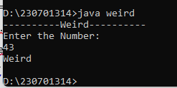

import java.util.Scanner;

import java.lang.Math;

public class form{

public static void main(String[] args){

Scanner sc = new Scanner(System.in);

System.out.println("enter number of queries");

int q = sc.nextInt();

while(q>0){

int sum = 0;

Double a = sc.nextDouble();

Double b = sc.nextDouble();

Double n = sc.nextDouble();

for(int i=0;n>0;n--){

sum=(int)(sum+(a+(Math.pow(2,i)*b)));

System.out.print(sum+" ");

i++;

}

System.out.print("\n");

q--;

}

}

}

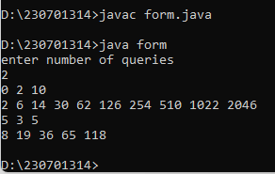

/*

import java.util.Scanner;

public class sumcalculator {

public static void main(String[] args) {

Scanner sc = new Scanner(System.in);

String repeat;

do {

System.out.print("Enter the first number: ");

double num1 = sc.nextDouble();

System.out.print("Enter the second number: ");

double num2 = sc.nextDouble();

double sum = num1 + num2;

System.out.println("The sum of "+num1+" and " +num2+ " is " +sum);

System.out.println(" want to continue again? (yes/no): ");

repeat=sc.nextLine();

} while (repeat=="yes");

System.out.println("Thank you for using the Sum Calculator!");

}

}

*/

import java.util.Scanner;

public class sumcalculator {

public static void main(String[] args) {

Scanner sc = new Scanner(System.in);

String repeat;

do {

System.out.print("Enter the first number: ");

double num1 = sc.nextDouble();

System.out.print("Enter the second number: ");

double num2 = sc.nextDouble();

double sum = num1 + num2;

System.out.println("The sum of " + num1 + " and " + num2 + " is " + sum);

sc.nextLine();

System.out.print("Do you want to continue again? (yes/no): ");

repeat = sc.nextLine();

} while (repeat.equalsIgnoreCase("yes"));

System.out.println("Thank you for using the Sum Calculator!");

sc.close(); // Close the scanner

}

}

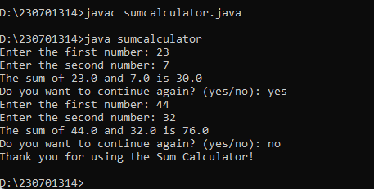

import java.util.Scanner;

public class minmax {

public static void main(String[] args) {

Scanner sc = new Scanner(System.in);

double number;

double largest = Double.NEGATIVE_INFINITY; //

double smallest = Double.POSITIVE_INFINITY; //

String repeat;

do {

System.out.print("Enter a number: ");

number = sc.nextDouble();

if (number > largest)

largest = number;

if (number < smallest)

smallest = number;

System.out.print("Do you want to enter another number? (yes/no): ");

sc.nextLine();

repeat = sc.nextLine();

} while (repeat.equalsIgnoreCase("yes"));

System.out.println("Largest number entered: " + largest);

System.out.println("Smallest number entered: " + smallest);

sc.close();

}

}

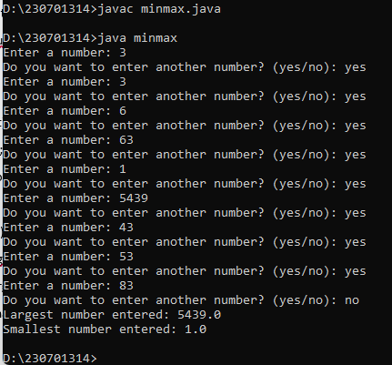

public class arms {

public static void main(String[] args) {

System.out.println("Armstrong numbers between 1 and 500:");

for (int number = 1; number <= 500; number++) {

if (isArm(number)) {

System.out.println(number);

}

}

}

public static boolean isArm(int num) {

int originalNum = num;

int soc = 0;

while (num > 0) {

int digit = num % 10;

soc += Math.pow(digit, 3);

num /= 10;

}

return originalNum == soc;

}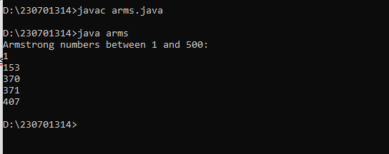

}

import java.util.Scanner;

public class ggame {

public static void main(String[] args) {

Scanner scanner = new Scanner(System.in);

int randomNumber = (int) (Math.random() * 100) + 1;

int guess;

boolean guessedCorrectly = false;

System.out.println("I'm thinking of a number between 1 and 100. Can you guess what it is?");

while (!guessedCorrectly) {

System.out.print("Enter your guess: ");

guess = scanner.nextInt();

if (guess == randomNumber) {

System.out.println("Congratulations! You guessed the number correctly.");

guessedCorrectly = true;

} else if (guess > randomNumber) {

System.out.println("Too high, try again.");

} else {

System.out.println("Too low, try again.");

}

}

scanner.close();

}

}

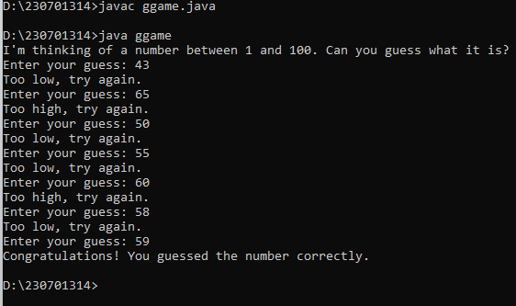

import java.util.Scanner;

public class ApproxLog {

static double findLn(int n) {

double ln = 0;

for (int i = 1; i <= n; i++) {

if (i % 2 == 0) {

ln -= 1.0 / i;

} else {

ln += 1.0 / i;

}

}

return ln;

}

public static void main(String[] args) {

Scanner scanner = new Scanner(System.in);

System.out.print("Enter a positive integer n: ");

int n = scanner.nextInt();

if (n > 0) {

double result = findLn(n);

System.out.printf("The natural logarithm of 2 using %d terms is approximately: %.10f%n", n, result);

} else {

System.out.println("Please enter a positive integer.");

}

scanner.close();

}

}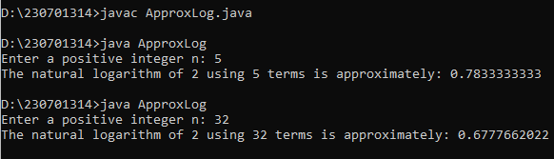

public class what {

public static void main(String[] args) {

for (int i = 0; i <= 25; i++) {

if (i == 10 || i == 12 || i == 20) {

continue;

}

System.out.print(i + " ");

}

}

}

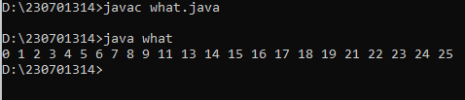

public class npy {

public static void main(String[] args) {

int n = 5;

for (int i = 1; i <= n; i++) {

for (int j = i; j < n; j++) {

System.out.print(" ");

}

for (int j = i; j >= 1; j--) {

System.out.print(j);

}

for (int j = 2; j <= i; j++) {

System.out.print(j);

}

System.out.println();

}

}

}

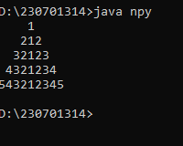

import java.util.Scanner;

public class CosineCalculator {

//factorial

public static long factorial(int num) {

long fact = 1;

for (int i = 2; i <= num; i++) {

fact *= i;

}

return fact;

}

public static double computeCosine(double x, int n) {

double cosine = 1.0;

for (int i = 1; i <= n; i++) {

double term = Math.pow(-1, i) * Math.pow(x, 2 * i) / factorial(2 * i);

cosine += term;

}

return cosine;

}

public static void main(String[] args) {

Scanner scanner = new Scanner(System.in);

System.out.print("Enter the value of x (in radians): ");

double x = scanner.nextDouble();

// Input n (number of terms)

System.out.print("Enter a positive integer n (number of terms): ");

int n = scanner.nextInt();

// n

if (n < 0) {

System.out.println("Please enter a positive integer for n.");

return;

// cosine calc

}

double cosineValue = computeCosine(x, n);

System.out.printf("The cosine of %.2f using %d terms is: %.6f%n", x, n, cosineValue);

scanner.close();

}

}

